**Lab Section (Day/Time)_______________________**

**Names of Student with ID#**

**Student ______Yixin Wang_______________________________ Marks ___________**

**EE 188L - Lab 6**

**Introduction to Operational Amplifier Circuits**

**NAU + CQUPT (Fall 2020)**

1. **Introduction**

The **Operational Amplifier (Op-Amp)** is a highly-sophisticated (complicated) **solid-state** (Transistors🡪next semester in EE 280) circuit **designed** to be used in many applications to make **mathematical relationships** between **input electrical signals** and **output electrical signals**. It is used primarily in **instrumentation** that produces **output voltage signals** that are a **mathematical function** of the **input voltage signals [Vout = f(Vin)]**.

The **basic properties** of the **ideal op-amp** have been introduced and discussed in class, along with **additional details and results** of those basic properties. Some of the **results** are not obvious at the first time that the student has seen them.

The **op-amp** has **2 DC voltage inputs** that supply **DC voltages** to it which **power** the transistor circuits inside—sometimes these are not shown in schematics. The **op-amp** has **2 signal inputs** and **1 signal output**. Additional ports (connections from inside the **op-amp** circuit to outside) may exist for some **op-amps**, but this lab does not require those.

As explained in class the **ports** and **properties** of the **ideal op-amp** are:

* ***vp =*> noninverting input** with respect to ground.
* ***vn* => inverting input** with respect to ground.
* ***vd* = *vp - vn* => difference input voltage** (Note: **not** with respect to ground).
* ***vo* => output** with respect to ground.
* **Rin = ∞ => input resistance between *vp*** and ***vn;*** this results that the **currents** into the **input ports *i+* & *i-* = 0**.
* **Rout = 0 => output resistance** at the ***vo* port**

The **Rin & Rout** values**🡪 no loading** at the **inputs** or **output**.

* **Avo = ∞ with infinite bandwidth (BW)**
* **No offset output voltage🡪** if ***vd,* *vp* &** ***vn* all = 0**, then ***vo* = 0**
* And an **external negative feedback path**.

The last **“property”** of the **ideal op-amp** is actually a fundamental of its design, which is its **external** **negative feedback (NFB) circuit path** from the **output port** to its **inverting input port (the “secret of the op-amp):**

The **op-amp senses** the **voltages** at ***vp*** and at ***vn*** 🡪 If ***vd* = *vp* –** ***vn* ever starts to become not = to 0, the op-amp provides *whatever it can*, through the feedback path, to drive *vd*  = *vp* –** ***vn* back to zero!**

A **block diagram** of a **general op-amp feedback system** is shown below. An **input circuit R-** goes to the **inverting input**; an **input circuit R+** goes to the **noninverting input**; and a **feedback circuit Zf** goes between the **output** and the **inverting input,** providing the **NFB path**. `

**Vin- Inverting ckt R- Feedback ckt Rf**

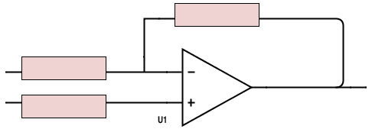

**Vin+ Noninverting ckt R+ Vout**

A brief **Table** of these properties of a **real Op-Amp** is given below. **Slew rate** and **CMRR** are additional properties that are not covered at this time. **100 dB = 10E5**

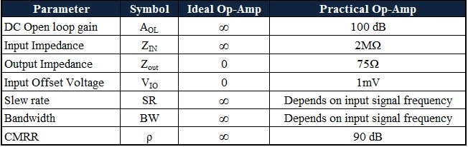

1. **Circuits and equipment**

**OBJECTIVE:**

To become familiar with the use and characteristics of a **741 op-amp** as an **ideal op-amp**, by building and testing the following circuits:

• Inverting Amplifier

• Non-inverting Amplifier

• Summing Inverting Amplifier

* Difference Amplifier

**MATERIALS:**

1. **741 Op-Amp**

2. Assorted Resistors

3. Function Generator

4. Digital Multimeter

5. Dual Channel Oscilloscope

6. Multiple output DC Power Supply

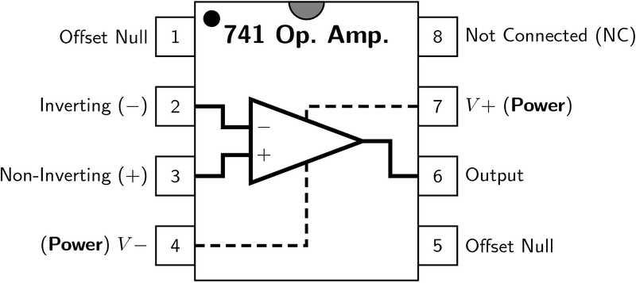

**PROCEDURE:**

**Comments:**

1. **Use +/- 15 volts for the Op-Amp DC voltages on pins 7 & 4. Follow the instructions on creating +/- voltages!!**
2. Use **0.01 to 1.0 AC sine wave signals**, depending on the circuit **amplifier gains**.
3. The **first 3** **circuits** use the **same values** for **Rin** and **Rf**: thus you will not need to completely **rebuild** each circuit from the beginning. The last one has **given** values for the resistors.
4. The **labels** for resistors may **be different** on the figures. You can figure out which is **Rf** and which is **Rin**, etc.

Sample circuit for an **inverting amplifier:**

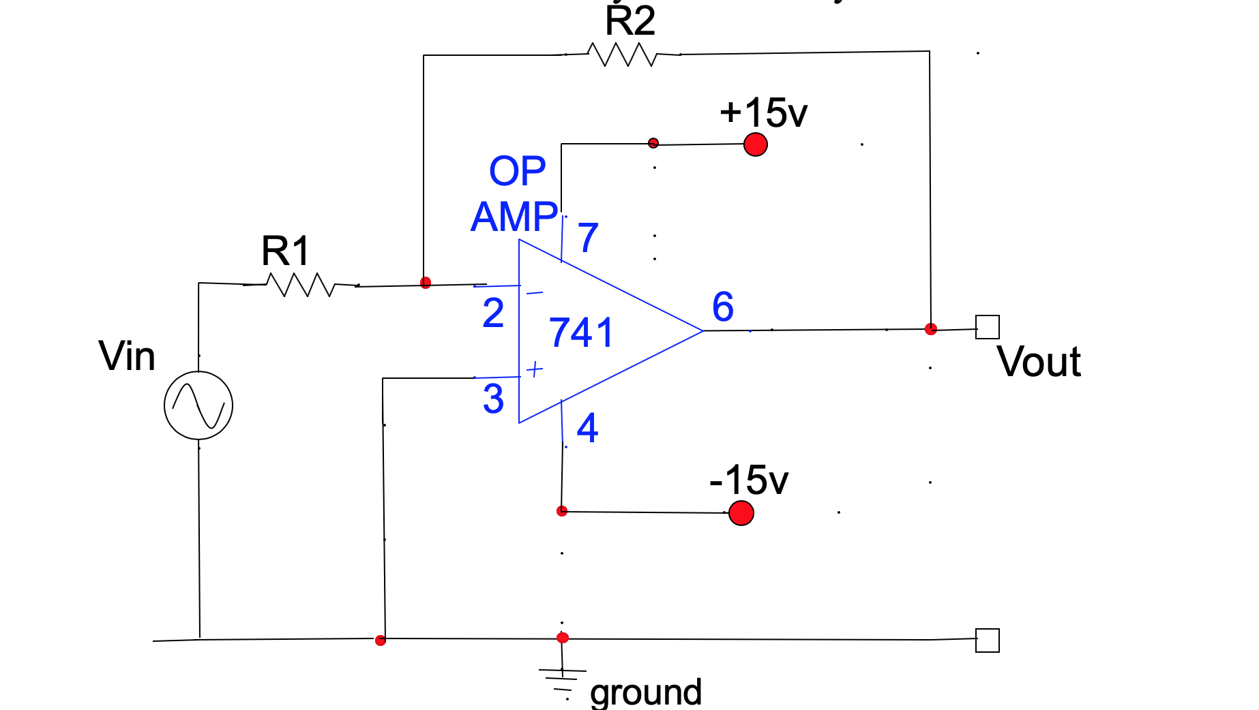

**Circuits to be built today:**

1. **Inverting Amplifier**

* **Design** a combination of **RF and Rin** (**Note**: not the same **Rin** as the input impedance of the ideal op-amp)for a calculated gain of **-10**; and record the calculated **gainVo/Vi**, for the circuit shown below. Assume an ideal op-amp. Use kΩ ranges.

**RF= 20** kΩ **and Rin= 2** kΩ

* Construct the circuit shown below, referring to the **figure above** for the **pin-out configuration** of the **741 op-amp**.
* For f = 100Hz, use a **sine wave** from the **FG**. Adjust the input to **0.4Vp_p** (peak-to-peak).

1. Measure and record **voltage gain** **Vo/Vin** . Compare with calculated value. Use **peak values**. **Measured gain=** 9.9 .
2. Find the **maximum peak-to-peak output voltage** without **distortion** by increasing the input voltage until Vo begins to clip: it should be a bit below the **±15VDC power sources** at pins **4** &**7**.
3. **Max input Vpp = 0.40 . Max output Vpp = 3.96 .**

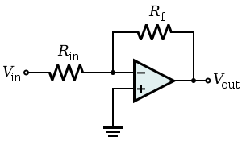

**Rin=__19.89___ kΩ Rf=___2.03__ kΩ**

* How were you able to find that the output is ‘inverted’?

Explain: By observing the phase of the input and output waveforms in the oscilloscope, the phase difference of 90 ° can be observed

1. **Noninverting Amplifier**

* **Design** a combination of **RF and R1** for a calculated gain of **+11**; and record the calculated **gainVo/Vi** for the circuit shown below. Assume an ideal op-amp. Use kΩ ranges.

**R1= 2** kΩ **and RF= 20** kΩ

* Construct the circuit shown below, referring to the **figure above** for the **pin-out configuration** of the **741 op-amp**.
* For **f = 100Hz**, use a **sine wave** from the **FG**. Adjust the input to **0.4Vp_p** (peak-to-peak)
* Measure and record **voltage gain** **Vo/Vin**. Compare with calculated value. **Measured gain=** 11.1 .
* Find the **maximum peak-to-peak output voltage** without **distortion** by increasing the input voltage until Vo begins to clip: they should be a bit below the **±15VDC power sources** at pins **4** &**7**.

**Max output Vpp = 4.44 .** **Max input Vpp = 0.40 .**

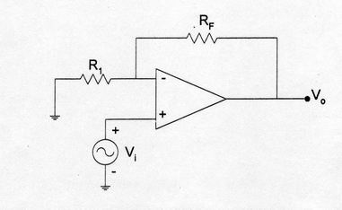

**R1=__20.1___ kΩ Rf=__1.99____ kΩ**

* How were you able to find that the output is ‘non-inverted’?

Explain: By observing the phase of the input and output waveforms in the oscilloscope, it can be observed that their phases are the same

1. **Difference Amplifier**

* **Design** the **difference amplifier** below, which has a **difference gain = 10**.

Use **kΩ range resistors**. **R1=R3= 2 kΩ , R2=R4=** 20 **kΩ**

* **Build** it and **verify** the **calculated difference gain**

**Measured gain= 10 .**

* **Using two channels of the FG, to produce two way input:** For **f = 100Hz**, use a **sine wave** from the **FG**. Adjust the input to

**V1pp = 0.1 V and V2pp = 0.5 V**

* **Output voltage Vpp = 3.88V**

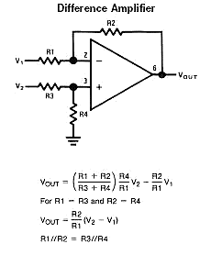

**R1=R3=_19.89___ kΩ R2=R4=_2.03____ kΩ**

* How were you able to find that the output is a ‘difference’?

Explain: It can be observed that the output VPP is 10 times bigger than the difference between the two inputs in the oscilloscope.

1. **Summing Amplifier**

* **Analyze** the **summing circuit** below and determine the **theoretical** **Vout** as a **function** of the **inputs V1, V2** and **V3**.

**theoretical** **Vout = __292mV_____**

* **Build** it and **verify by measurement** the **predicted output** for **V1 = V2** = **V3 = 0.01 Volts AC, sine wave, f=100Hz.**

**🡪** Just apply the **same voltage** to all 3 inputs.

* Record output voltage **Vpp = 296mV**

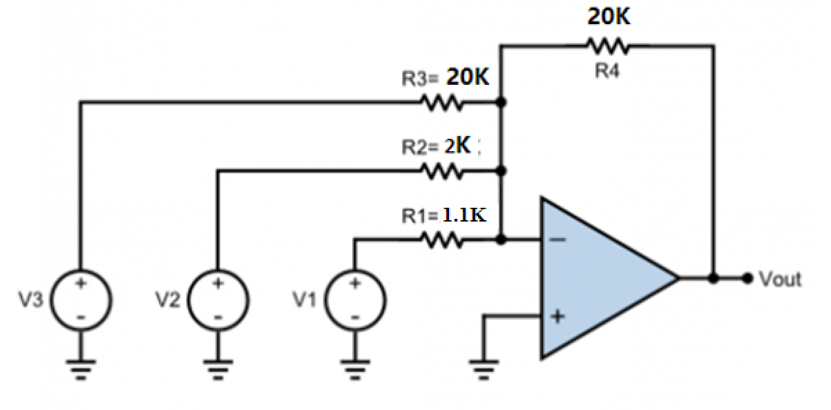

* How were you able to find that the output is ‘summed’?

Explain: It can be observed that the output VPP is the weighted sum of the three inputs in the oscilloscope.

